**Activity: How to view a report**

**Introduction**

To work as a Power BI analyst, you need to understand Power BI’s features, functionalities, and capabilities. In this activity, you’ll be guided through a Power BI project and explore Power BI’s interactive features and functionalities. From navigating report pages and interacting with visuals to customizing views and exporting reports, you'll gain hands-on experience in Power BI.

**Instructions**

**Open a Power BI report (.pbix) file**

1. Download the provided *Sales and Returns Sample.pbix*file.

[Sales & Returns Sample](https://d3c33hcgiwev3.cloudfront.net/zbBvUetST4u8vCLJmbZDXQ_3c030a94a0ab45f997afa737befed8f1_Sales-Returns-Sample.pbix?Expires=1708732800&Signature=dxqC-5UVjyajIwFjQZSUEk13nEoWK-aguji~B7Y4jDeLgI17U2AwblMk-2gV9BKXt78SrwQ3CpJgfABfbQVFVTl6fKUdCqJbmxtKy8Sc-YZn6uoypsOALQnm3MvQkYsxX-W8nwP4gRH323jqA3wL13He0PdVHZg86sElcbNmvlQ_&Key-Pair-Id=APKAJLTNE6QMUY6HBC5A" \t "_blank)

[PBIX File](https://d3c33hcgiwev3.cloudfront.net/zbBvUetST4u8vCLJmbZDXQ_3c030a94a0ab45f997afa737befed8f1_Sales-Returns-Sample.pbix?Expires=1708732800&Signature=dxqC-5UVjyajIwFjQZSUEk13nEoWK-aguji~B7Y4jDeLgI17U2AwblMk-2gV9BKXt78SrwQ3CpJgfABfbQVFVTl6fKUdCqJbmxtKy8Sc-YZn6uoypsOALQnm3MvQkYsxX-W8nwP4gRH323jqA3wL13He0PdVHZg86sElcbNmvlQ_&Key-Pair-Id=APKAJLTNE6QMUY6HBC5A" \t "_blank)

1. Launch Power BI Desktop.

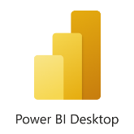

1. Select **Open other reports** in the welcome screen or go to **File** in the top left corner and then select **Open**.

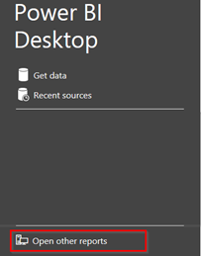

1. Browse to the location where your .pbix file is stored, select the file, and click **Open**.

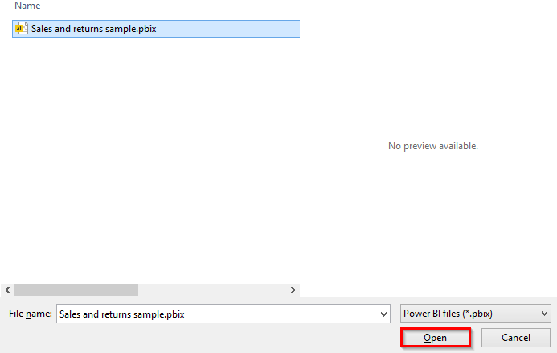

**Explore the Power BI interface**

Locate and familiarize yourself with the following sections of the Power BI interface:

1. **Ribbon:** The ribbon, located at the top of the screen, contains various tools and features to help you create and modify reports.

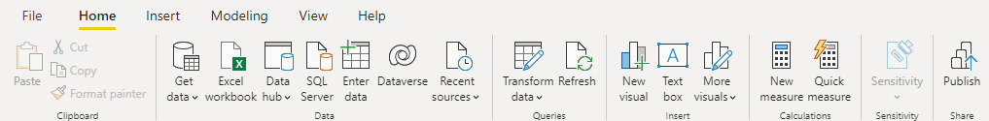

1. **Report View:** This is the main working area where you'll create and edit visualizations.

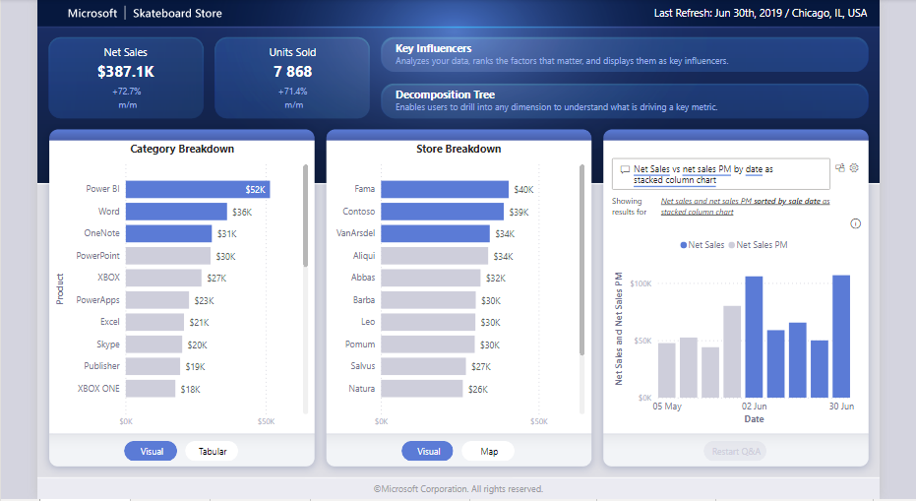

1. **Pages:** Located at the bottom of the screen, the Pages section allows you to switch between different report pages.

The Net Sales tab

1. **Visualizations Pane:** Located on the right side of the screen, this pane displays a list of available visualizations that you can add to your report.

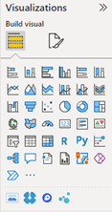

1. **Fields Pane:** Located next to the Visualizations Pane, the Fields Pane displays a list of available data fields from the data model that can be added to visualizations.

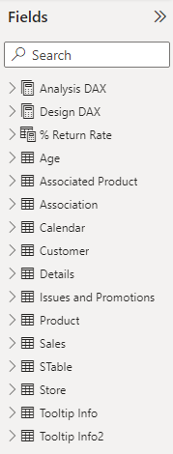

**Navigate report pages**

1. Locate the **Report View**, which should be automatically opened when you open the *Sales and returns sample.pbix* file. If not, select the **Report** icon in the left-hand pane.

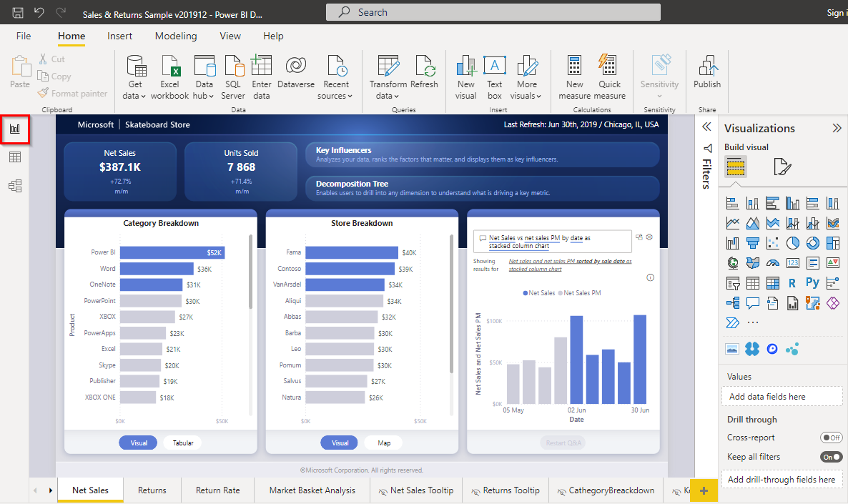

1. To switch between report pages, select the **page tabs** located at the bottom of the screen.

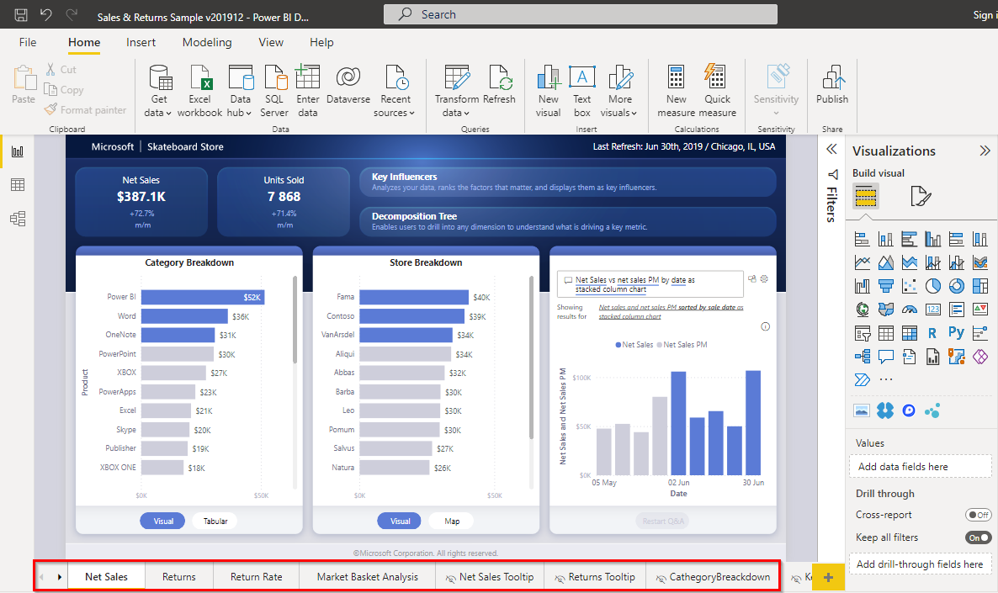

1. To add a new page, select the **+** icon next to the existing pages.

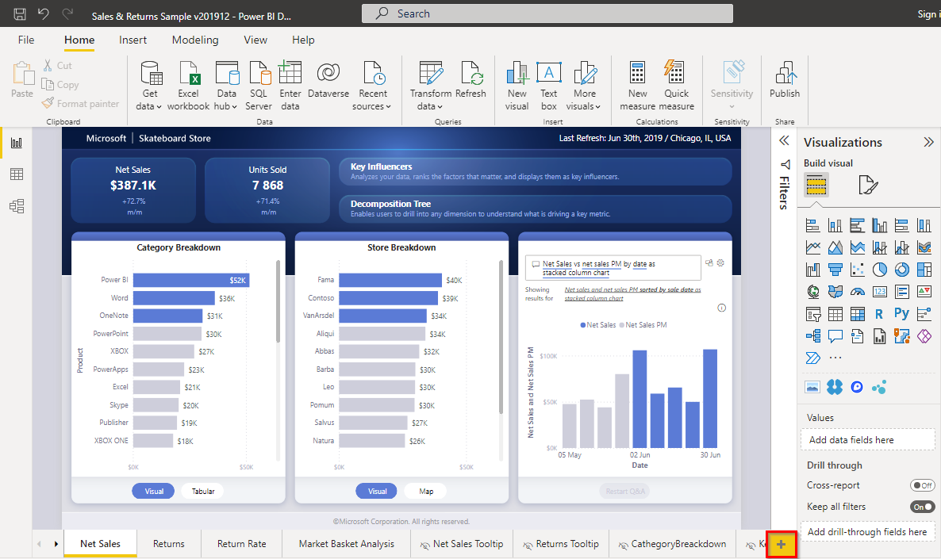

1. To delete or duplicate a page, right-click on the page tab and select **Delete** or **Duplicate**.

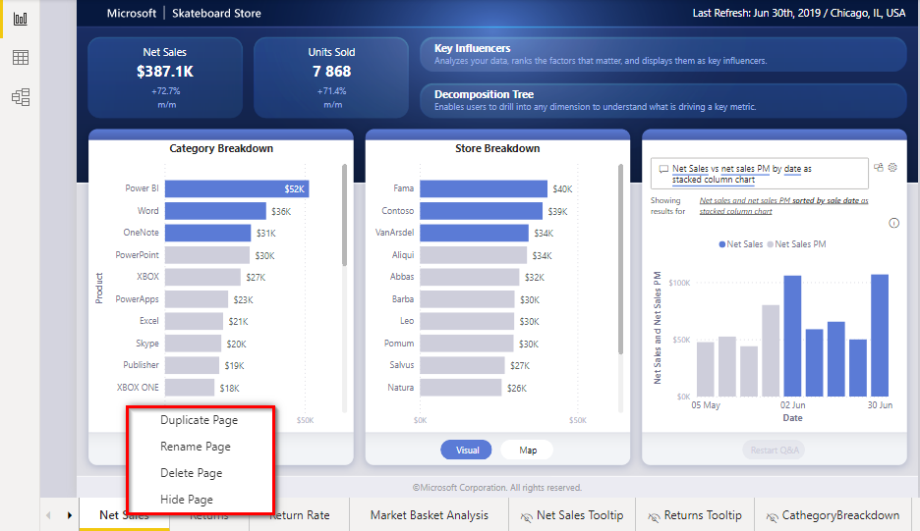

**Interact with visualizations**

1. To select a visualization, select it within the **Report View**.

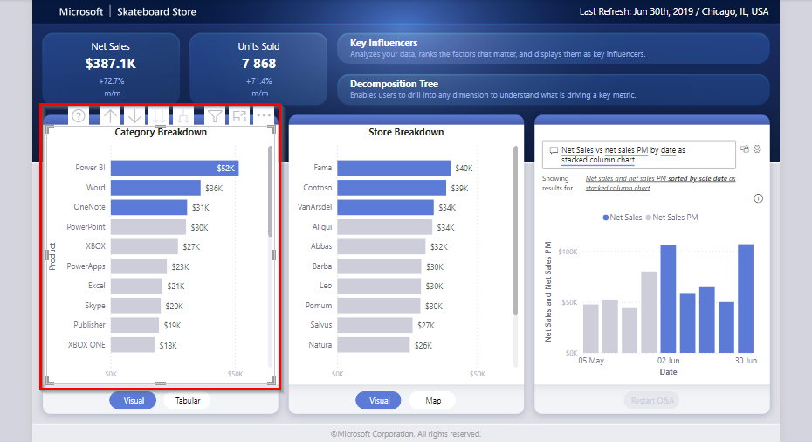

1. To move a visualization, select and drag it to the desired location.

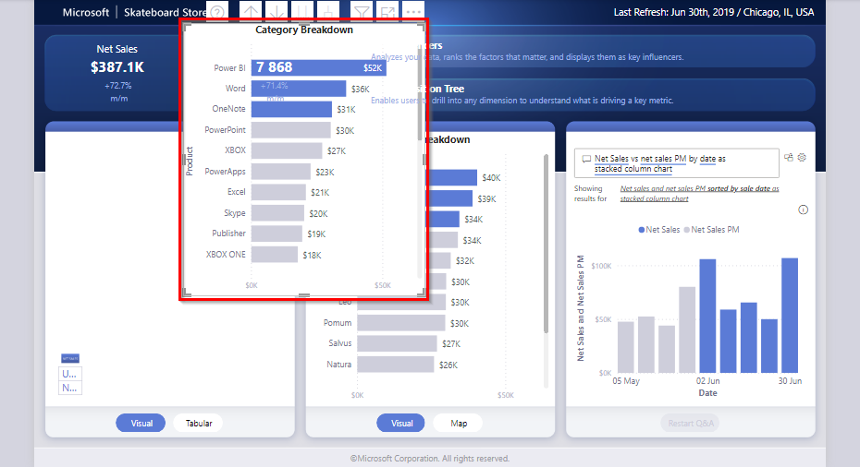

1. To resize a visualization, select and drag the **small borders** located at the edges of the visualization.

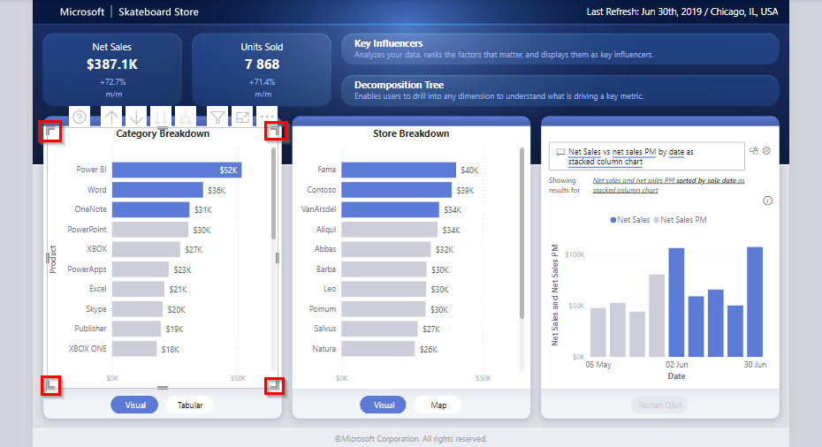

1. To access additional options, such as sort by, spotlight, or export data, select the **ellipsis** (three dots) located at the top-right corner of the visualization.

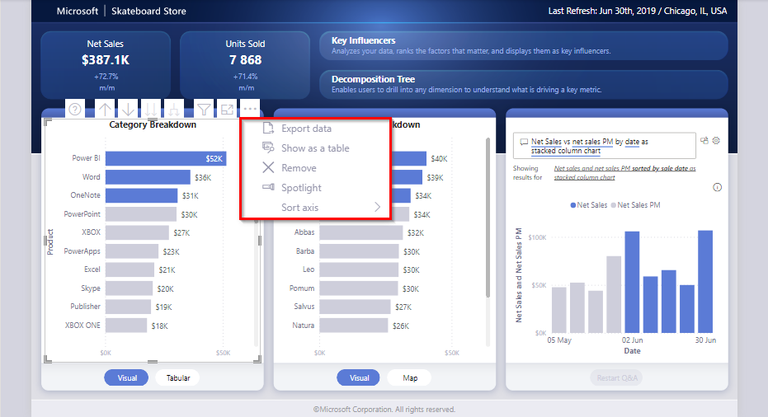

**Interact with the report**

1. Hover over different data points, bars, or lines in the visuals to view **tooltips** with additional information.

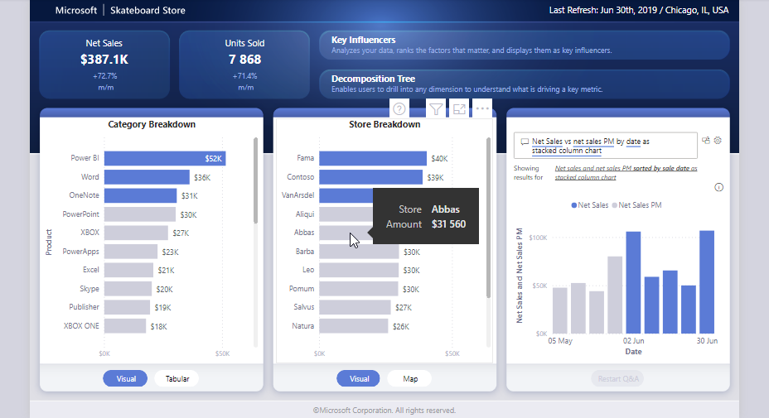

1. Select specific **data points** or **categories** in the visuals to filter or cross-highlight related visuals in the report.

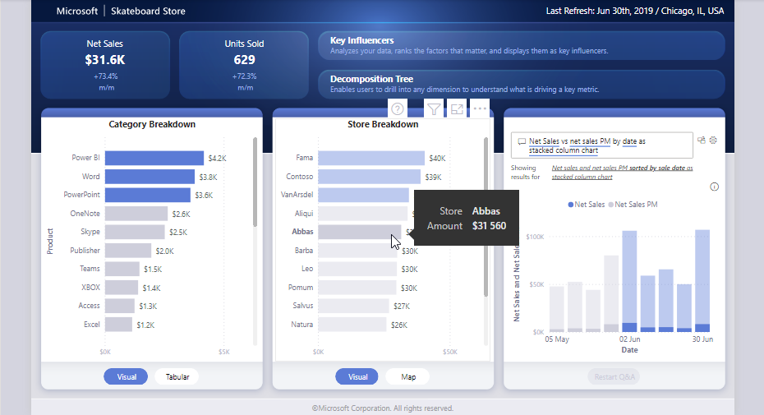

**Drill down into the data**

1. Locate visuals with the **drill down functionality** enabled (usually indicated by a single or double-arrow icon in the visual's top-right corner).

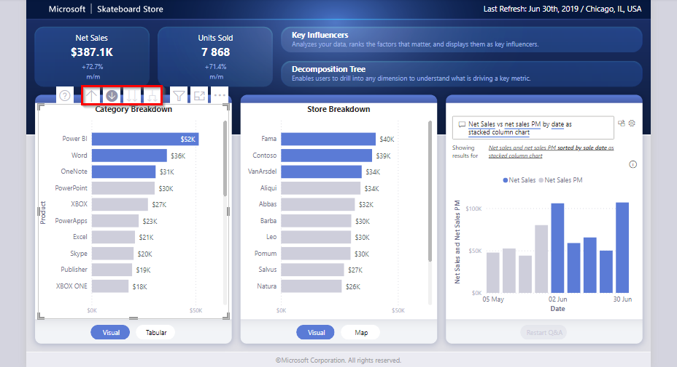

1. Select the **drill down** button and then select a data point to view more granular data.

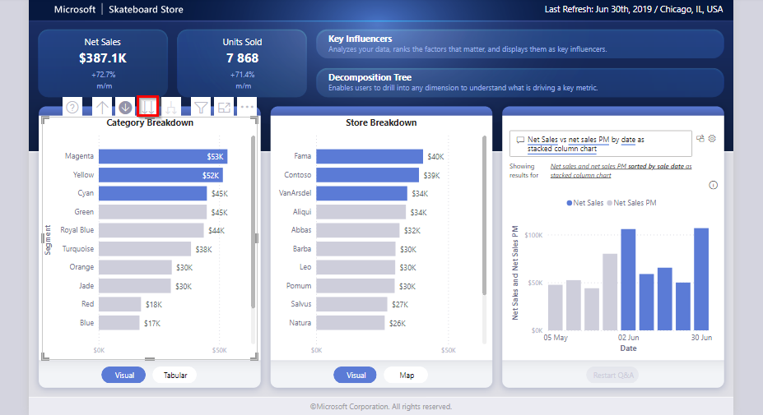

1. Use the **drill up** button (a single upward-facing arrow) to return to the previous level of the visual.

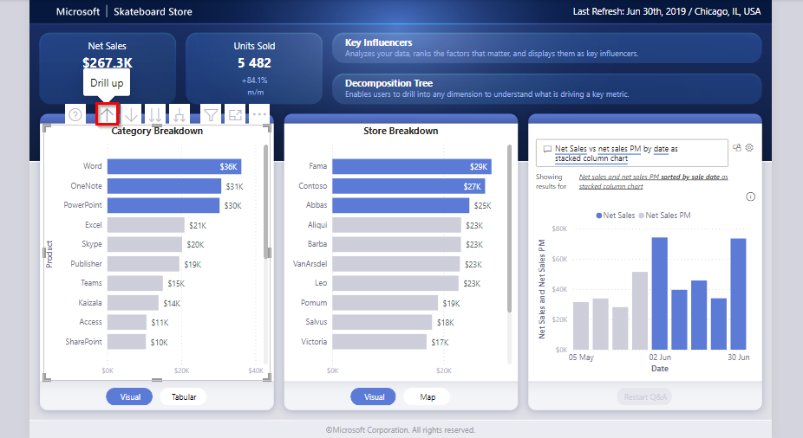

**Conclusion**

In this activity, you navigated a Power BI report (.pbix file), exploring Power BI’s interface and some of the available features and functionalities. By following these steps, you gained hands-on experience with navigating a report and some of the skills necessary for using the Power BI interface to tackle real-world data challenges head-on.